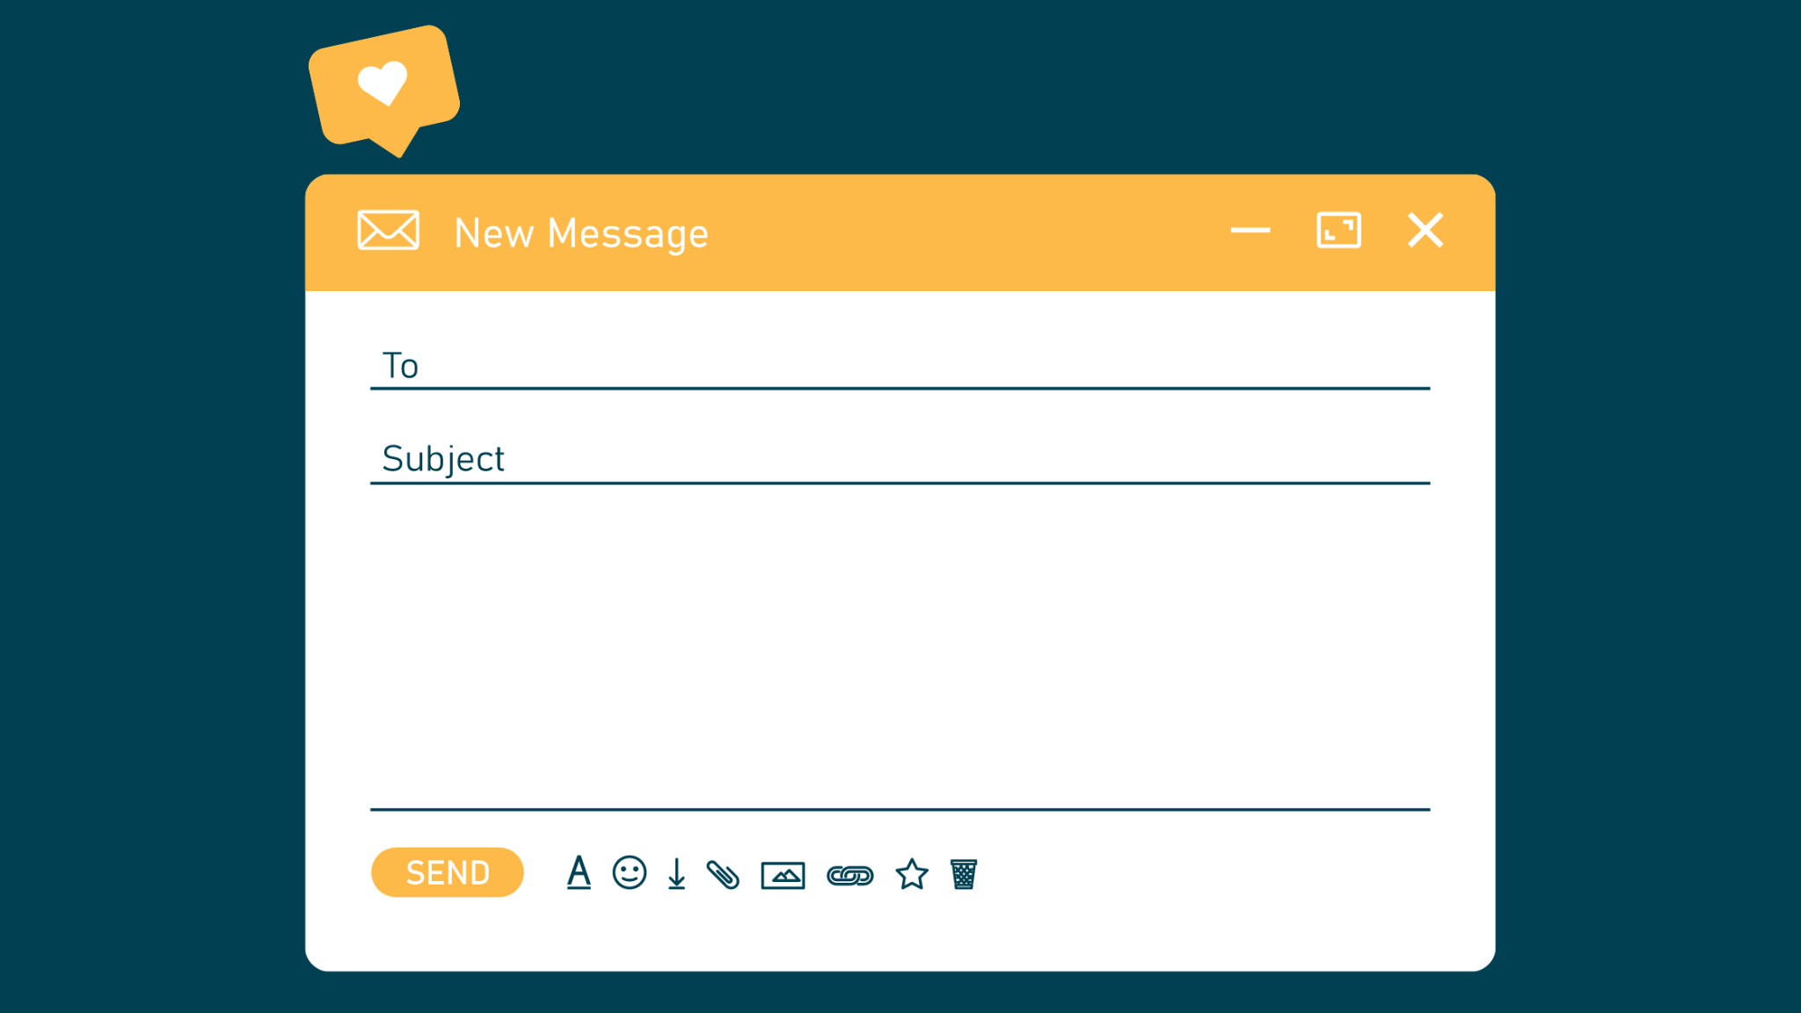

12 Standout Mid-Funnel Email Frameworks

The typical mid-funnel email is totally forgettable. It blends in, when it should stand out. That’s because most reps build them with tired old templates, stale snippets, and stock phrases.

But you can change that. For your buyers — and your win rate — using these emails.

1/ The Discovery Preview

A prospect’s interest in giving you their time for a discovery call has likely decreased — not increased — since confirming your meeting time. Build up their interest again:

Subject: < Your Company Name >, Our Call
< Prospect >, excited for our call later this week.

After the call, I want both of us to have a clear point of view on how we can help you < outcome >.

One thing I’ll share to that end is how < a non-obvious insight: we know X, while most think Y >.

Anything else you want to make sure we cover?

2/ Post Discovery & Pre-Demo

Use your buyer’s words to play back key points from a call, ensure they feel heard, and showcase their logic for why they should move forward with another call. Include:

[1] A clear problem statement.

[2] How they want to approach the problem.

[3] What needs to be true of a solution for it to fit.

[4] Next steps, referencing a colleague who’s impacted.

Here’s how it reads:

Subject: Recap, < Their Company > & < Your Company >

< Prospect >, thanks for such an open, thoughtful conversation.

You shared that despite trying < failed solution >, your team still can’t < desired outcome >.

That's because of < problem >, which is costing < cost of problem >, and it's getting worse.

You also felt the most effective way to go about solving this is < logical approach >.

But for this to work in your case, you need to ensure < key questions for demo >.

Looking forward to digging into this with < colleagues > on < demo date >.

3/ Post-Demo Follow-Up

The typical post-demo email is a stack of links, padded with pleasant comments. “Link-stacking" puts the work back on the buyer, and it’s too product centric.

Switch it up by using your buyer’s words to fill in this framework like a game of Mad Libs:

[1] Contrast current vs. future process.

[2] Recap the logical approach they’re sold on.

[3] Create dramatic tension. If we do this… good. If not… bad.

[4] Share how your product delivers on the good outcome.

[5] Add a CTA based on how the email needs to “travel.”

Here’s how it reads:

Subject: Re: Recap, < Their Company > & < Your Company >
< Prospects >, appreciated the transparent feedback earlier.

You mentioned that instead of < current process >, you’d like to < future process >.

Which will enable you to < approach — e.g. more product-qualified leads = faster cycle times >.

Ideally, this leads to < good outcomes — dropping cycle times from 60 to 40 days>.
(Love how < prospect > mentioned it’d let them < personal goal, e.g. take that vacay to Hawaii > )

But if this change isn’t made before < timing >, you’ll be looking at < cost of the problem >.

To avoid that, here’s a recap on how < successful customer > partners with < product >.

Since < colleague > owns < project, e.g. marketing site >, think we could get her input?

4/ The “Forwardable” Follow-Up

Most reps send emails to their champions, when they should send them through their champions. Forwardables package your message so it's easy to forward, and loop in key contacts.

The 5 steps in this framework are:

[1] Open up with a company-wide initiative.

[2] Reference a trigger phrase that’s familiar.

[3] Stir up emotion using visual language.

[4] Create tension through a challenge.

[5] Match your ask to the decider’s job.

Here’s how it reads:

Subject: < Internal Project Name >
< Prospect >, you mentioned your team (especially < Key Contact >) is working on < big initiative >.

The goal is “ < internal trigger phrase > “, ideally < measurable outcome >.

I can almost read the press release now:
< Bold, compelling headline that’s exciting to key contact >.

To make that happen, though, you need to < remove this problem and specific roadblock >.

So we built out a shortlist of ways < your company > can help, attached here.

Guessing < key contact > might want to weigh in too?

5/ The “Idea” Follow-Up
Buyers don't forget you sell a product. So they don't need the reminder. Instead, try this follow-up email focused on helping buyers get their job done today. The elements in this framework are:

[1] Recall a past topic.
[2] Align it with a tool or idea.
[3] Confirm this is still a priority.
[4] Give proof your idea is helpful.

Here’s how it reads:

Subject: Idea, < Job To Be Done >
< Prospect >, last we spoke, < their challenge, paraphrase their words > was a big focus.

I was just discussing < content/resource/tool > and thought of you.

Are you still working on < goal related to the challenge >?

If so, check it out <link>.

From what I'm seeing, I have an idea for how you could use it too.

If it's still relevant, let's connect.

‍

6/ The “No-Reply-Required” Follow-Up

Ideally, an executive is sponsoring your deal early on. After they introduce you to their team, you’ll want to keep them in the loop on your progress — but without the burden of a reply.

This one’s pretty short and sweet.

Here’s how it reads:

Subject: Update, < Deal Focus >
< Executive >, we’re making good progress exploring < problem / focus area >.

Suspringinsly, < an interesting finding or discovery you’ve made with their team >.

We also have < activity > planned for next week, and will keep you posted.

Feel free to join of course, but no reply needed — just keeping you in the loop.

‍

7/ The “Consensus” Follow-Up
Complex deals are complex because of the number of contacts involved, and the need to create consensus from multiple sets of priorities and incentives.

When you see a way to tie together multiple goals in the buying committee, use this framework:

[1] Develop urgency by referencing a shared date or deadline.
[2] Connect that date back to each buyer’s personal goals.
[3] Link both of their goals together, using your product.

Here’s an example, where James is the Head of Sales, and Daniel is the Head of Marketing:

Subject: Trial-Free PQL’s

James, Daniel, you both mentioned Q4 is a make-or-break quarter.

It’s when James needs a shorter sales cycle, and Daniel needs to boost lead quality.

After last week, I think we’re aligned on an approach to ties both of these goals together:

> Creating more product-qualified leads, but without offering free trials.

Have a second to walk through a pre-Q4 plan I sketched out for you?

‍

8/ The “Account Team” Follow-Up

This one is crazy effective when executed well, and to genuinely help. Here's how to use it for high-value, late-stage deals:

- Partner with your account team (could be a CSM, AM, or solutions engineer).
- Pick a few late-stage deals and detail the customer's current state.
- Find one way you both can help the buyer today.
- Give your team this email to send to you (the rep).
- Forward that email on to your buyer.

It's effective because:

- I can almost guarantee no competitor is doing this.
- It shows your buyers there's a whole team thinking about them.
- It actually "adds value" by helping buyers get a job done.
- It sets up a smooth handoff and implementation.

Here’s an example.

Let's say you work with an operations team who doesn't have a master data hierarchy. Which throws off their segmentation and causes all kinds of issues. So you and your team modify a sample from another account and schedule a working session to refine it.
‍Subject: Meeting < Prospect >

Hey < Sales Rep >, how's it going with < Prospect >?

I know they’re not a customer yet. But from what you shared, I can’t wait to work with them.

Think they’d be open to connecting with me next week?

Most < role, e.g. marketing > teams at this stage < problem, e.g. don't have a data hierarchy >.

Since that's the case for them too, we can use this < framework > to start building theirs out.

It'll either make their onboarding easier, or, help them even if they don’t end up working with us.

Think they'd be open to it?

9/ The “Objections” Follow-Up

It’s never ideal to handle objections over email, without understanding the issue more deeply. So this framework’s goal is to set up a call, and signal you’re there to listen and collaborate. It works by:

[1] Showing you’re grateful they’ve raised an issue (instead of ghosting).
[2] “Actively reading” to isolate the objection into one core concern.
[3] Seeking to understand, before jumping right into a solution.

Here's an example of how this reads:

Subject: Re: < Objection >

< Buyer >, thanks so much for sharing where you're coming from.

It sounds like < isolate the main objection > is the key concern for you here.

Which is something I should have addressed for you sooner — forgive me on this.

I have a thought to run by you, but it'd be helpful to understand more context from your point of view first. (Does this relate to < objection raised previously >?)

Open to a short call to share more with me?

‍

10/ The “I’m Behind” Follow-Up

Sometimes, you need a little extra time to be thoughtful, so use this email as an alternative to:

- Sending an uninspiring, default template on-time.
- Sending a killer follow-up that's way late.

This one’s all about communicating consistently. Just don't use it multiple times on the same account.

Subject: On the Way

Ally, I mentioned following up on our conversation by tonight.

Turns out, that timing was a little ambitious (I was excited about our conversation).

I'd like to invest a little more time to build a more thoughtful recap and set of suggestions.

This way, it'll land better with your team. We can share it with them by Friday.

Will that timing work okay for you?

-nate

‍

11/ Reviewing Pricing

If you have a truly complex pricing model with multiple drivers and options, it’s rarely ideal to email over pricing without a conversation. Use the “4A’s” framework instead:

[1] Acknowledge the group’s needs.
[2] Affirm the goals of your pricing structure.
[3] Ask for feedback on the options created.
[4] Align with the right contacts in a conversation.

Here's how it reads:

Subject: <Company Name>, Contract Feedback

< Prospect >, thinking we have a good handle on the full group’s needs now.

Also helpful to hear < Brittany's > goal on keeping your recurring spend low.

So I rolled both of these inputs into a set of contract options for us to look at.

Could the three of us put our heads together on feedback later this week?

By the way, if procurement hasn’t been involved yet, add a spin on this email by saying:

We’re both looking to set up a long-term relationship, and I’m sure your procurement team can help align our contract details with their vendor strategy.

Could we invite them, too?‍

‍

12/ The Closed-Won Feedback Email

At the risk of overstating it, this email can change the way you sell.

It’s fairly common to ask buyers for their ‘decision process,' and what they let you see is helpful. But it’s what you don’t see about the way your buyers buy that’s most valuable.

Here’s how to learn how your buyer's “internal sale” really goes down:

- Pick a deal that closed recently. Make sure you have an open, transparent champion.
- Write up the decision process you know, from what you heard and helped with.
- Ask your champion to point out any gaps. What did they do that you didn’t see?

What you find will be fascinating.

Subject: Process Feedback

<Prospect>, thrilled we get to work together now. All because of what you did behind the scenes.

There was definitely room for me to have been a stronger partner for you along the way, too.

So I’m wondering, open to helping me understand the work you were doing internally?

It'd be interesting to compare how I think you evaluated us vs. how your team actually did.

(e.g. the emails, conversations, docs, I never saw, but you worked so hard on.)

Lunch on me if you’re up for it?

Want to write better emails & sales materials?
Check out The Buyer Enablement Crash Course:

> https://www.sellingwith.io/ <

